Experiment no.:07 Keerthika.K-241901046
Comparison of two Files for forensics investigation by Compare IT software
Aim
To compare two files for forensic investigation using Compare It software.
Procedure
- Install the Compare It software on the system.
- Open the Compare It tool.
- A window will appear to select the files to be compared.
- Select the first file and click Open.
- Select the second file and click Open.
- The software displays both files side by side.
- Examine the highlighted sections to identify differences between the two files.
- Analyze the changes displayed in the comparison window.
- Use the available options to move changes between files, if required.
- Generate or print a report showing the differences between the files.
- Record the observations for forensic investigation.
Observation
Compare It software displays two files side by side and highlights the differences using colored sections. This makes it easier to identify changes and analyze the contents of the files. The software also provides an option to print a report of the differences.
Observation Table
S. No. | Particulars | Observation
1 | Tool Used | Compare It
2 | Purpose | Comparison of two files
3 | First File | A.txt
4 | Second File | B.txt
5 | Comparison Method | Side-by-side comparison
6 | Differences | Highlighted differences displayed by the tool
7 | Report | Difference report, if generated
8 | Status | Record the actual comparison result

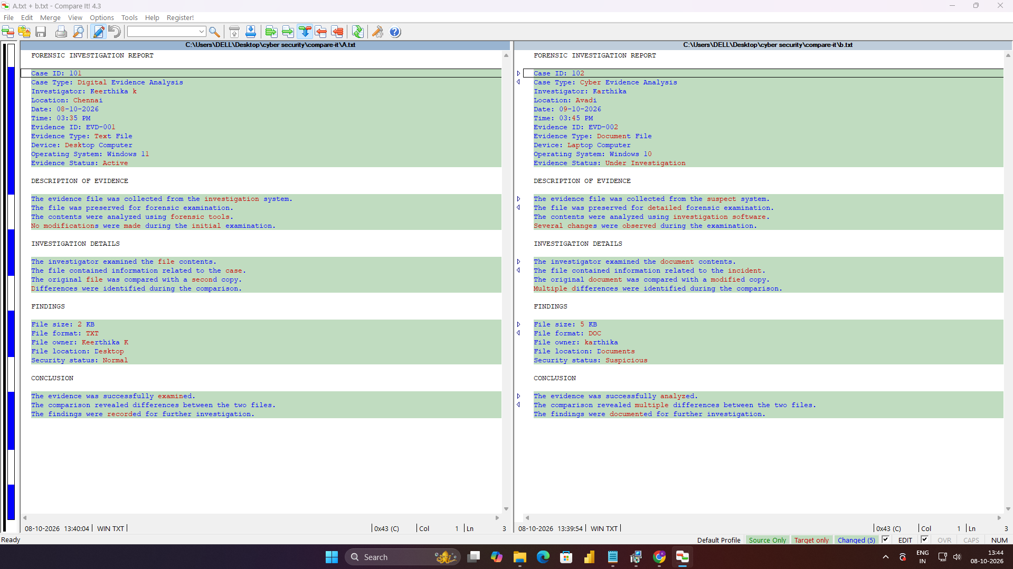

Result
Thus, two files were compared using Compare It software, and the highlighted differences were examined for forensic investigation.

